Medical History Disclosure Form

Name: ___________________________Age & Date of Birth: ___________________________
Emergency Contact:_____________________
Email Address: _________________________ Phone Number:__________________________

What areas of the body (i.e. Neck, Left hip, Right Shoulder, etc.) or conditions (i.e. Fatigue, Arthritis, etc) are you currently seeking care for?

If there are multiple areas of involvement, which region/problem is of greatest concern at this time?

Have you ever been treated for this same problem before?
If so, when & who treated this problem (i.e. 1999 by John Smith, DC & Jane Jones, MSPT)?
Did prior treatment successfully manage or resolve the problem at that time?

Please circle any/all illnesses you’ve either had in the past or currently have:

Cardiovascular disease Asthma/Breathing difficulty Hepatitis/Liver disease Depression
High Blood Pressure Congestive Heart Failure Epilepsy/Seizures Anemia
Diabetes (I or II) Multiple Sclerosis Thyroid condition Osteoporosis
Stroke or Heart Attack Fibromyalgia Neurological condition Chronic infections
Arthritis (Osteo/Rheum) Migraines/Headaches Eating disorder Lupus
Kidney/Renal disease Dizzy/Vertigo Drug or Alcohol abuse HIV/AIDS
Cancer (Type __________________; Location(s) _____________________________; Year ____________
Status ___________________________)
Other: _________________________________________________________________________________

Do you have a pacemaker, internal defibrillator, insulin pump, metal fixator, or any other implanted medical device?

Please list all prescription medications you are presently taking & reason for medication (i.e., Prozac for Depression, Percocet for pain, Accupril for High Blood Pressure):

Are you currently pregnant or is there even a possibility you might be pregnant?

What type of exercise and/or sports, if any, do you perform or participate in?

I CERTIFY, TO THE BEST OF MY KNOWLEDGE, THAT THE ABOVE INFORMATION IS COMPLETE & TRUE. IF MY MEDICAL/HEALTH STATUS CHANGES I WILL INFORM YOU IMMEDIATELY.

Signature & Date: _______________________________________________________________

Please mark the body diagrams with the following letters to indicate what you have been recently experiencing: P = Pain; T = Tightness; N = Numbness/Tingling; W = Weakness.

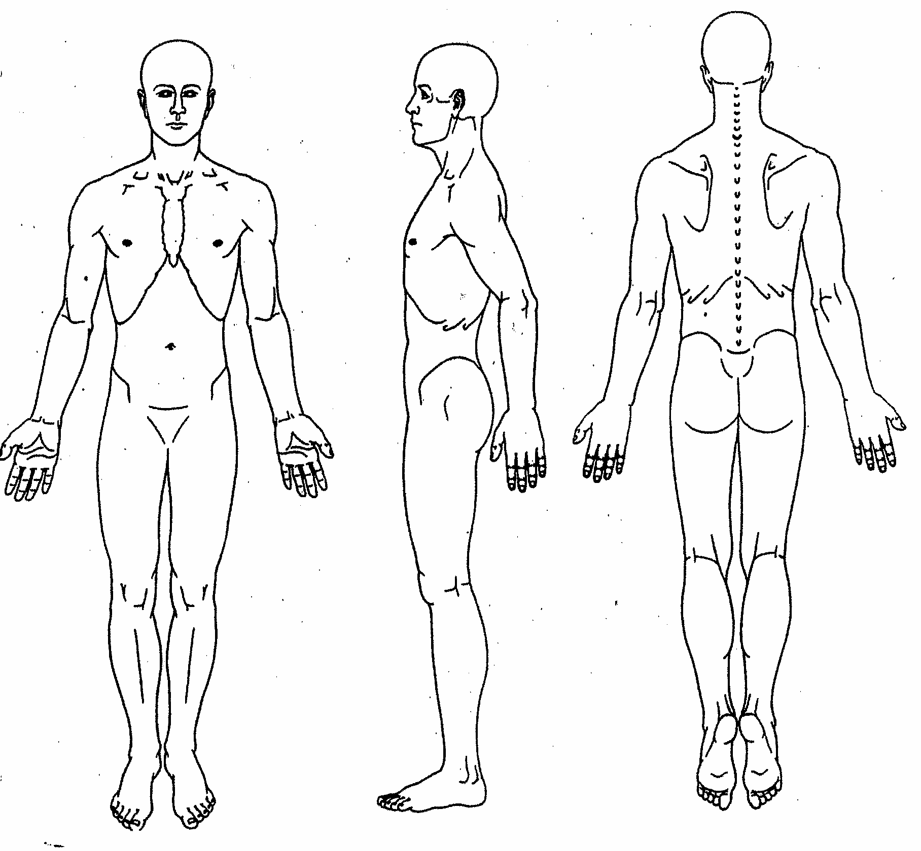

Next to each letter, please write a corresponding number (0 through 10) that conveys the intensity of your experience.

0=No pain, 10=Emergency Room pain)

